International Cybersecurity and Digital Forensics Academy (ICDFA)
CIP-B103: Network Forensics Fundamentals
LAB 2: HTTP Analysis Using Wireshark - Embedded Image Traffic
Three-Week Delivery Block 1/3 | 18-19 July 2026
Prepared by: Aminu Idris, AMCPN | Founder, ICDFA
Important Pre-Lab Instruction
Read the matching lecture slide deck before executing the practical. Work only inside the ICDFA-approved lab or your own isolated virtual environment. Record every command, observation and screenshot as contemporaneous evidence.
Course Code | CIP-B103
Course Title | Network Forensics Fundamentals
Lab Number | Lab 2
Lab Title | HTTP Analysis Using Wireshark - Embedded Image Traffic
Student Name | Fuseini Kantuogaa Imoru
Instructors Name | Dr. Sarah James
Delivery Block | 1/3 of 3
Scheduled Dates | 18-19 July 2026
Estimated Duration | 3-4 hours practical work plus report writing
Mode | Individual practical lab in an authorized virtual environment
Required Evidence | image_traffic.pcapng generated locally; webpage and image objects

1. Source Materials and Slide Alignment
- HTTP, Wireshark and Digital Forensics Part 2: webpages containing embedded images, multiple HTTP GET requests, TCP segmentation/reassembly and object extraction.
- The slide sequence demonstrates image.html and building.jpg, HTTP 200 responses, large payloads split across TCP segments, Export Objects and size relationships.
- The assignment requires browser-generated capture, insertion of a photograph, extraction of that photograph and explanation of curl/browser differences.
Reading Requirement Before Lab Execution
The lab deliberately follows the sequence, terminology and core exercises presented in the uploaded CIP-B103 slides. Commands have been corrected where needed for Linux syntax and forensic repeatability.

2. Lab Scenario
A web page and an embedded image were transferred over plaintext HTTP. Your task is to capture the transaction, prove that the browser requested two objects, reconstruct the segmented image response, export the image from the capture and verify that the recovered object matches the original.

3. Learning Outcomes
- Explain why one webpage can generate multiple HTTP requests and responses.
- Capture a browser request for HTML and an embedded image.
- Identify TCP segments that form one reassembled HTTP response.
- Calculate and explain IP length, TCP payload length and HTTP object size relationships.
- Extract an image using Wireshark Export Objects and tshark.
- Hash the original and extracted image and assess integrity.
- Document limitations caused by cache, HTTPS or incomplete capture.

4. Legal, Ethical and Safety Rules
- Use only systems, packet captures and networks for which you have explicit authorization.
- Keep the lab isolated from production, campus, office and public networks. Use NAT or host-only virtual networking as instructed.
- Do not collect, disclose or reuse real credentials, personal messages or confidential traffic.
- Preserve original capture files. Perform analysis on verified working copies and record SHA-256 hashes.
- Stop any traffic-generation or interception process immediately after the required evidence is captured.
- Restore firewall, ARP, forwarding and network settings before closing the lab.

5. Required Tools and Environment
Item | Recommended Tool | Purpose
Operating system | Kali Linux plus optional Windows 10/11 VM | Host the page and generate a browser request.
Web server | Apache2 | Serve image.html and the selected image.
Capture tools | Wireshark and tshark | Capture and reconstruct HTTP objects.
Browser | Firefox, Chrome or Edge | Generate separate HTML and image requests.
Utilities | curl, file, identify, sha256sum | Inspect and verify objects.
Image | Student-owned non-sensitive JPG/PNG | Embedded evidence object.

6. Lab Folder Structure and Evidence Preparation
mkdir -p ~/CIP-B103-Lab2/{evidence,working,exported,reports,screenshots,scripts}
cd ~/CIP-B103-Lab2
pwd
find . -maxdepth 1 -type d -print
Create the folder structure before downloading or generating evidence. Store original captures under evidence and analysis copies under working.
sudo apt update
sudo apt install -y apache2 curl wireshark tshark imagemagick
sudo systemctl enable --now apache2
cp /PATH/TO/YOUR/PHOTO.jpg /var/www/html/lab_photo.jpg
printf '<!DOCTYPE html>\n<html><body><h1>CIP-B103 Image Traffic</h1><p>Analyst: YOUR NAME</p><img src="lab_photo.jpg" alt="Training image"></body></html>\n' | sudo tee /var/www/html/image.html
sha256sum /var/www/html/image.html /var/www/html/lab_photo.jpg | tee reports/source_object_hashes.txt
Screenshot required: The source webpage, source image file information and their SHA-256 hashes.
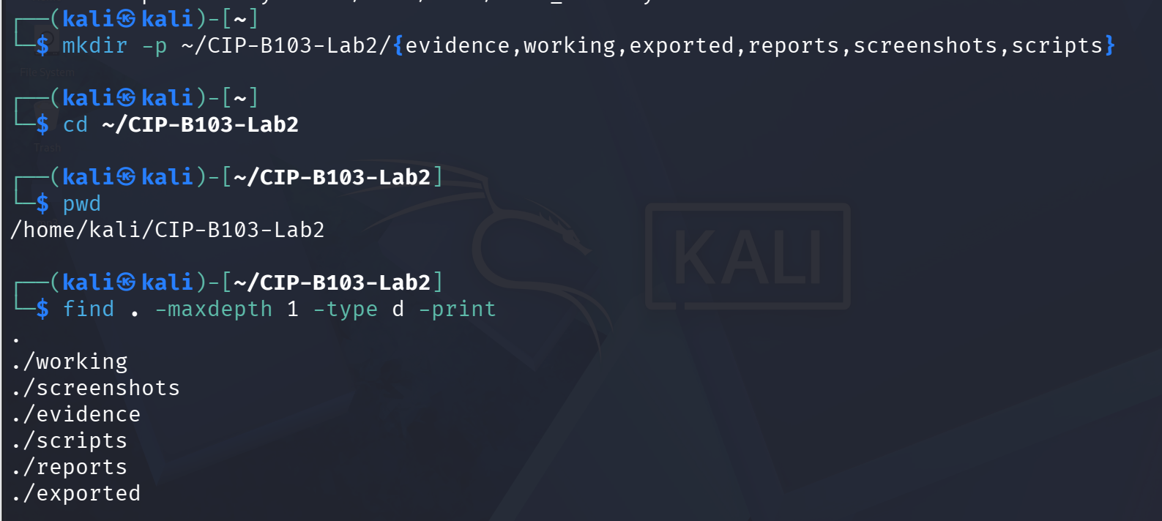
Screenshot 1: Evidence folder structure created (evidence, working, exported, reports, screenshots, scripts).
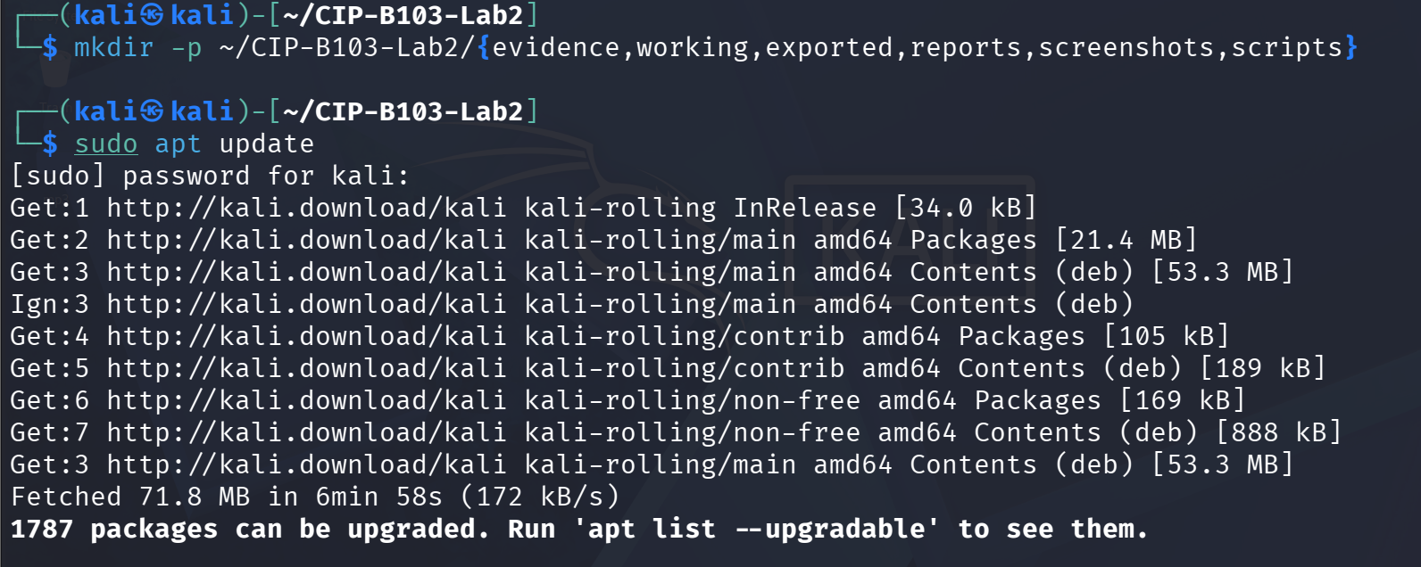
Screenshot 2: Package repositories updated (sudo apt update).
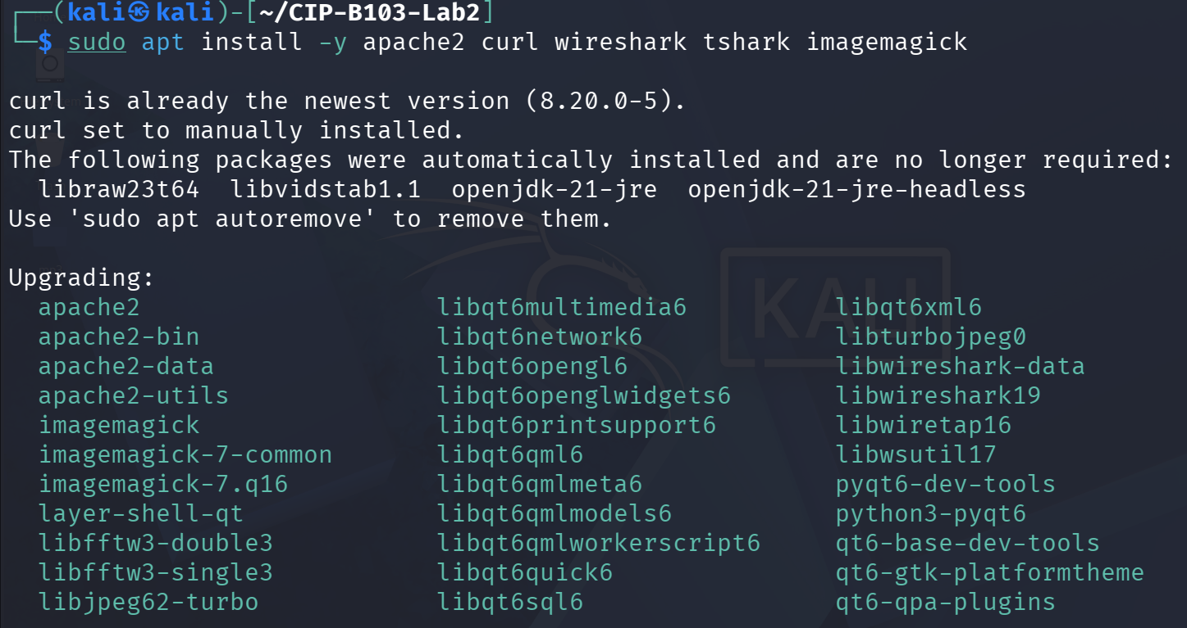
Screenshot 3: Required tools installed (apache2, curl, wireshark, tshark, imagemagick).
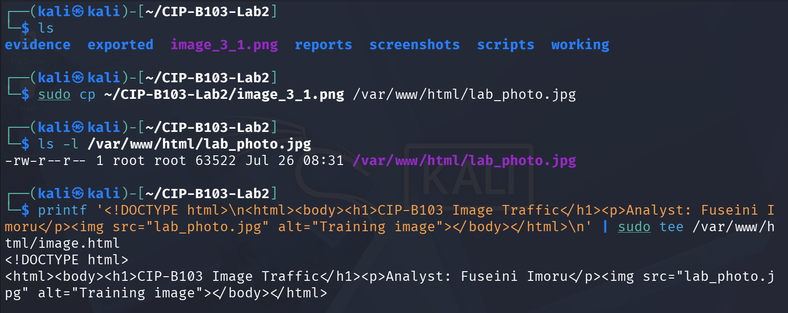
Screenshot 4: Source image copied to the web root and image.html generated with printf.
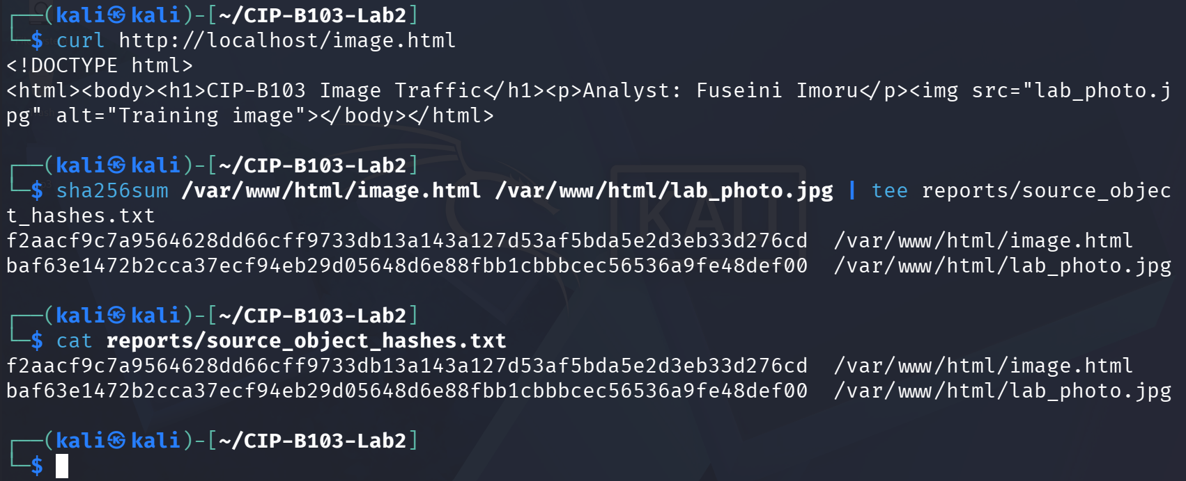
Screenshot 5: Local curl retrieval of image.html and SHA-256 hashes of the source objects.

7. Mini Evidence and Chain-of-Custody Worksheet
Field | Student Entry
Case/lab identifier | CIP-B103-Lab2-YourFullName
Trainee name | Fuseini Kantuogaa Imoru
Date and time started | 26 July 2026, 08:31 local (Kali VM system clock)
Evidence file name(s) | image_traffic.pcapng; curl_only.pcapng
Source or generation method | Browser-generated HTTP capture via tshark on loopback interface (lo), Apache2 serving image.html and lab_photo.jpg on 127.0.0.1
Original SHA-256 | 839742e84e9a32bef8d9a86c563b9bb66debccee3e8ce96bee3aa2da2914243f (image_traffic.pcapng)
Working-copy SHA-256 | 839742e84e9a32bef8d9a86c563b9bb66debccee3e8ce96bee3aa2da2914243f (image_traffic_working.pcapng) — identical to original
Analysis workstation/VM | Kali Linux (user: kali), CIP-B103-Lab2 working directory
Notes on any changes | None. cp --preserve=timestamps used; SHA-256 of evidence and working copies matched exactly, confirming no alteration.

8. Part A - Verify the Webpage and Eliminate Cache Effects
- Use a non-sensitive image you are authorized to submit.
- Open a private/incognito browser window or clear the cache before capture.
- Confirm that image.html displays both text and the embedded image.
- Record file type, dimensions and size of the source image.
file /var/www/html/lab_photo.jpg
identify /var/www/html/lab_photo.jpg
ls -lh /var/www/html/image.html /var/www/html/lab_photo.jpg
curl -I http://127.0.0.1/image.html
curl -I http://127.0.0.1/lab_photo.jpg
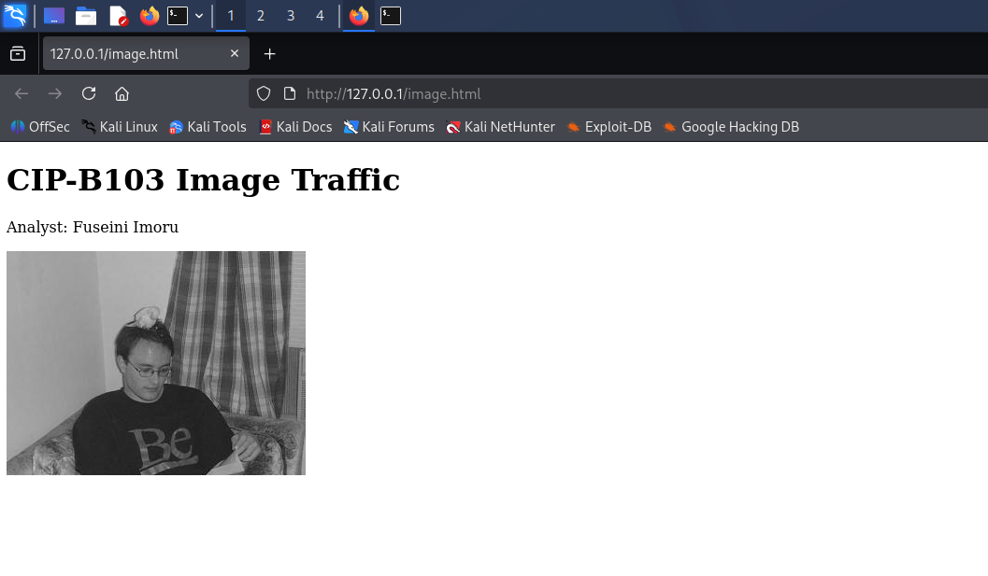
Screenshot 6: image.html rendered in the browser, showing the embedded photograph and analyst caption.
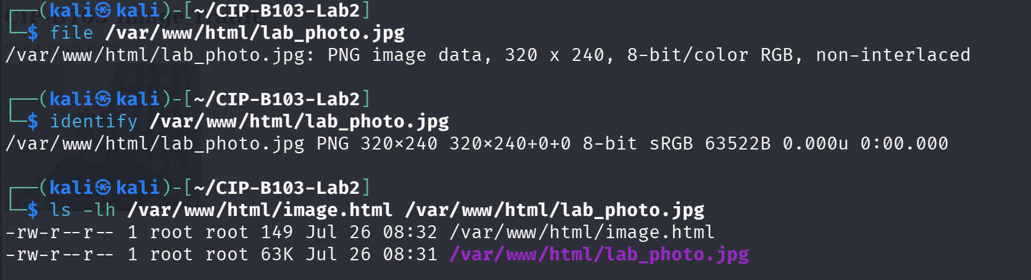
Screenshot 7: file/identify output confirming source image type and dimensions, plus ls -lh sizes.
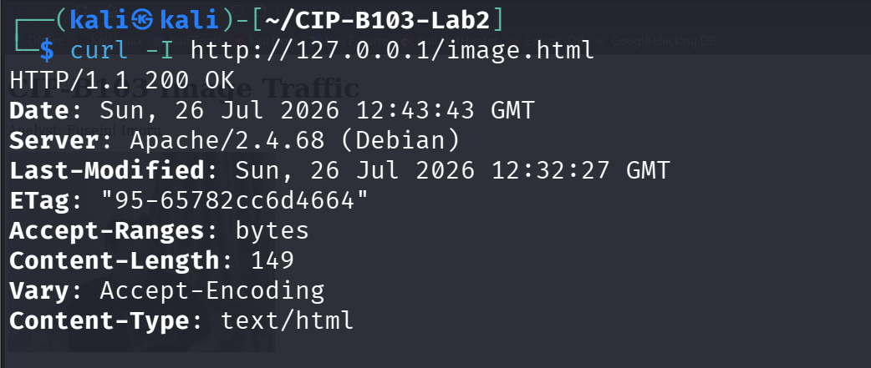
Screenshot 8: curl -I response headers for image.html (200 OK, Content-Length 149).
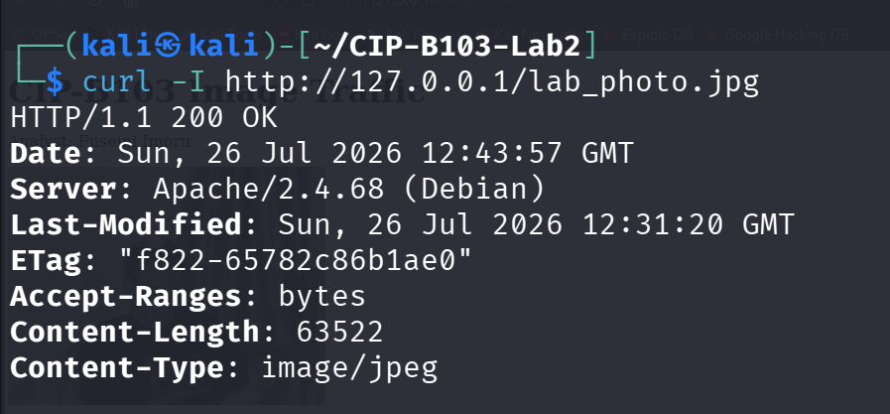
Screenshot 9: curl -I response headers for lab_photo.jpg (200 OK, Content-Length 63522, image/jpeg).

9. Part B - Capture Browser-Generated HTTP Traffic
# Terminal 1
sudo tshark -i lo -f 'tcp port 80' -w evidence/image_traffic.pcapng
# Browser
# Open a private window and visit: http://127.0.0.1/image.html
# Wait for the image to load, then stop the capture with Ctrl+C.
cp --preserve=timestamps evidence/image_traffic.pcapng working/image_traffic_working.pcapng
sha256sum evidence/image_traffic.pcapng working/image_traffic_working.pcapng | tee reports/capture_hashes.txt
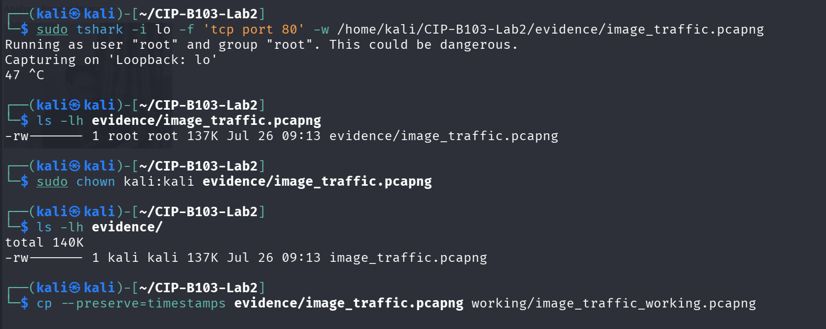
Screenshot 10: tshark capture started on loopback (tcp port 80) and evidence file written.
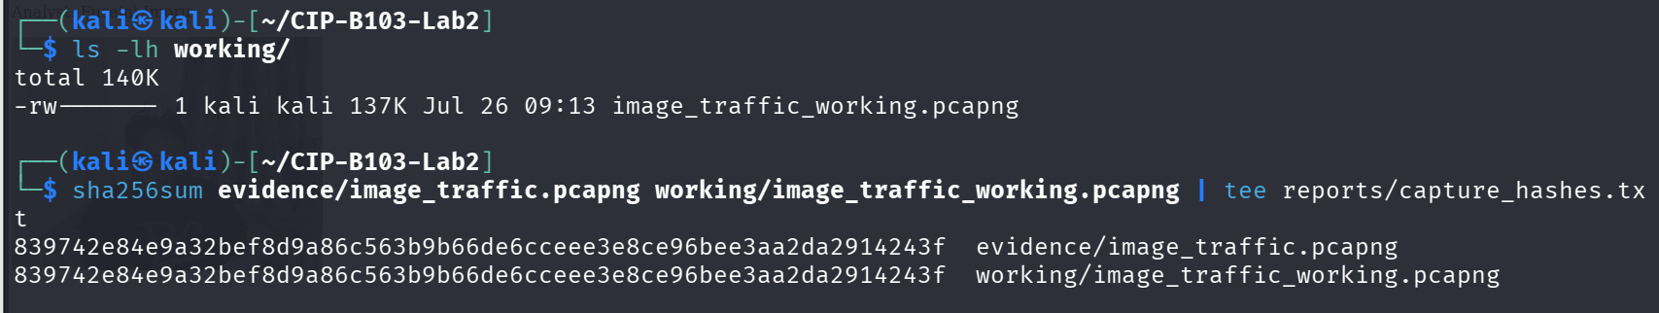
Screenshot 11: Capture hashed and copied to a working copy (sha256sum, cp --preserve=timestamps).
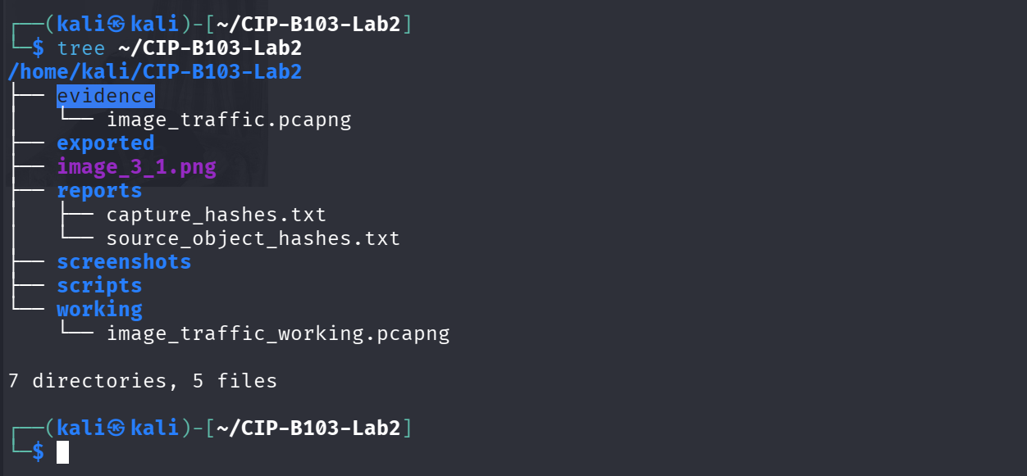
Screenshot 12: Evidence folder tree after Part B capture.

10. Part C - Prove That Two Objects Were Requested
Apply http.request. You should normally see one GET request for image.html and another for lab_photo.jpg. A favicon or browser-generated request may also appear; document it rather than deleting it.
tshark -r working/image_traffic_working.pcapng -Y 'http.request' -T fields \
-e frame.number -e frame.time -e tcp.stream -e ip.src -e tcp.srcport -e ip.dst -e tcp.dstport \
-e http.request.method -e http.request.uri -e http.host \
| tee reports/http_object_requests.tsv
tshark -r working/image_traffic_working.pcapng -Y 'http.response' -T fields \
-e frame.number -e frame.time -e tcp.stream -e http.response.code -e http.content_type -e http.content_length \
| tee reports/http_object_responses.tsv
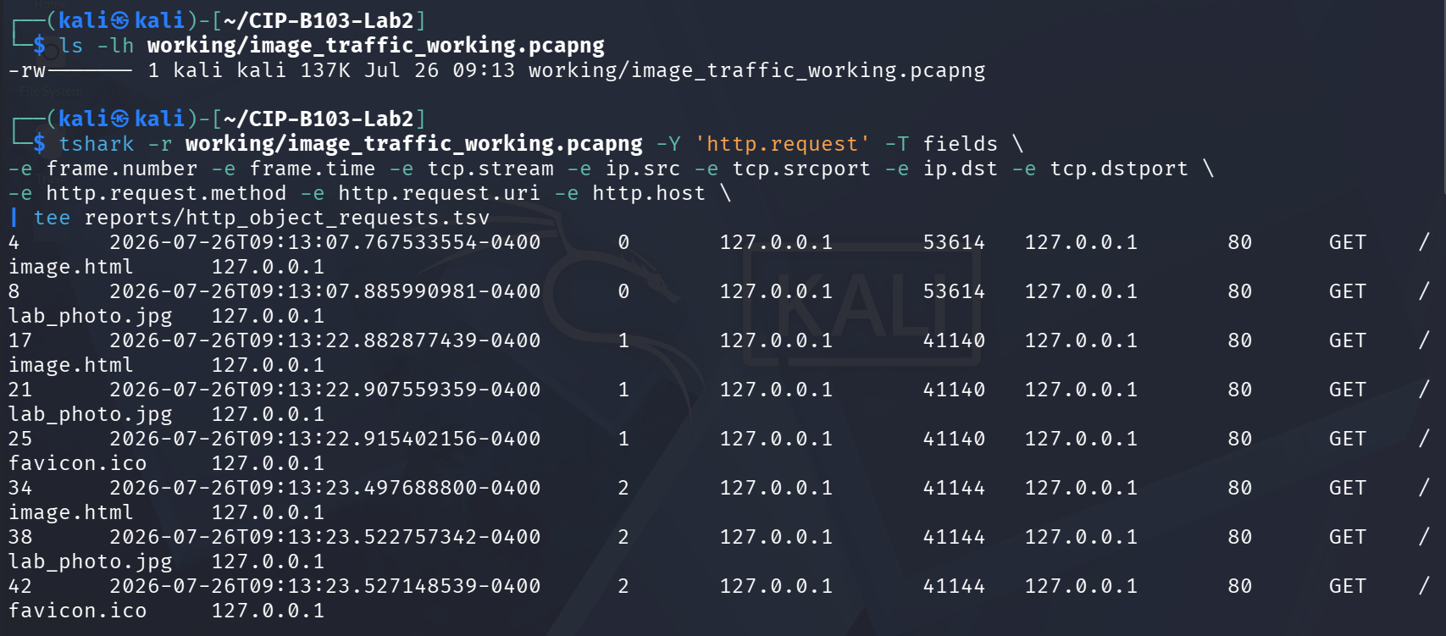
Screenshot 13: http.request filter output listing GET requests for image.html and lab_photo.jpg.
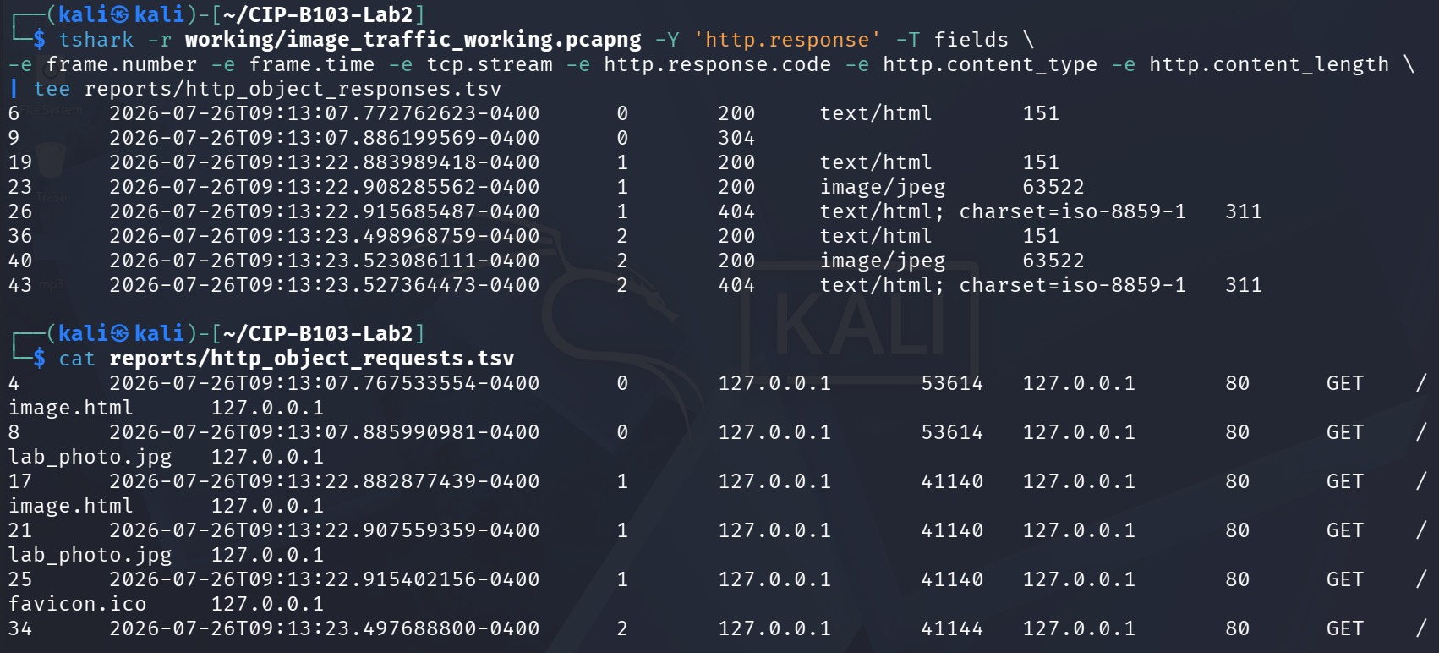
Screenshot 14: http.response filter output showing response codes and content lengths.
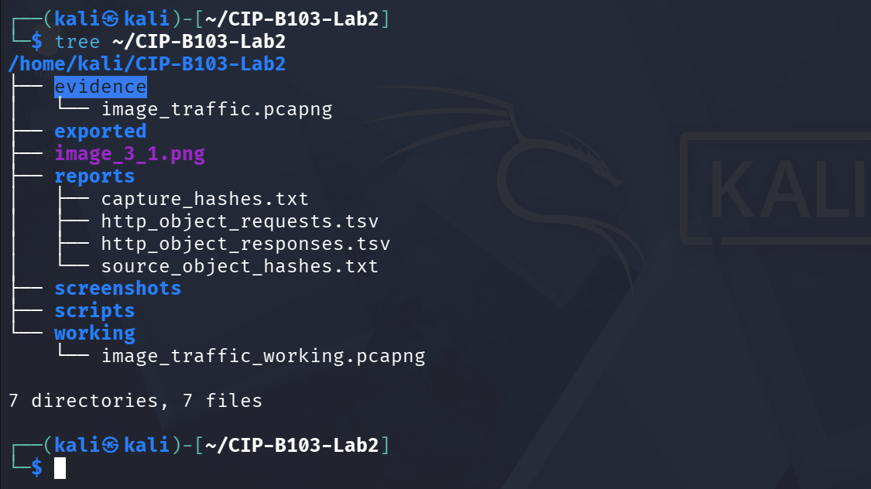
Screenshot 15: Reports folder tree after Part C HTTP inventory exports.
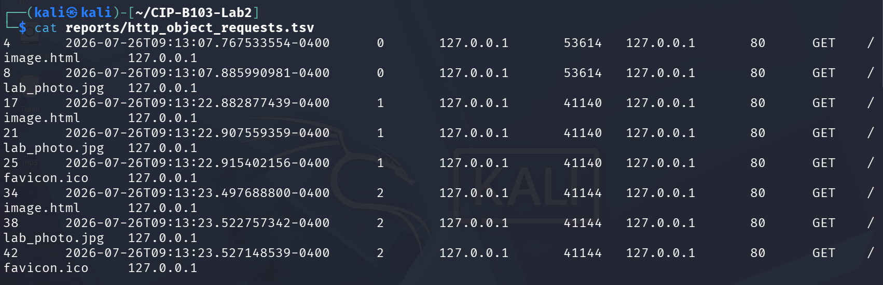
Screenshot 16: Contents of reports/http_object_requests.tsv.

11. Part D - Analyze TCP Segmentation and Reassembly
- Select the HTTP response associated with the image request and note Reassembled TCP Segments.
- Record the number and tcp.len value of each contributing segment.
- Add the TCP payload lengths and compare the result with the HTTP header plus object data.
- Explain why the exact segment sizes may differ from those in the slide: interface offloading, operating system buffers, MTU and capture location can change segmentation.
# Replace STREAM with the tcp.stream number for the image transfer
tshark -r working/image_traffic_working.pcapng -Y 'tcp.stream==STREAM && tcp.len>0' -T fields \
-e frame.number -e frame.time -e ip.len -e tcp.hdr_len -e tcp.len -e tcp.seq -e tcp.ack \
| tee reports/image_stream_segments.tsv
# Summary of conversation sizes
tshark -r working/image_traffic_working.pcapng -q -z conv,tcp | tee reports/tcp_conversations.txt
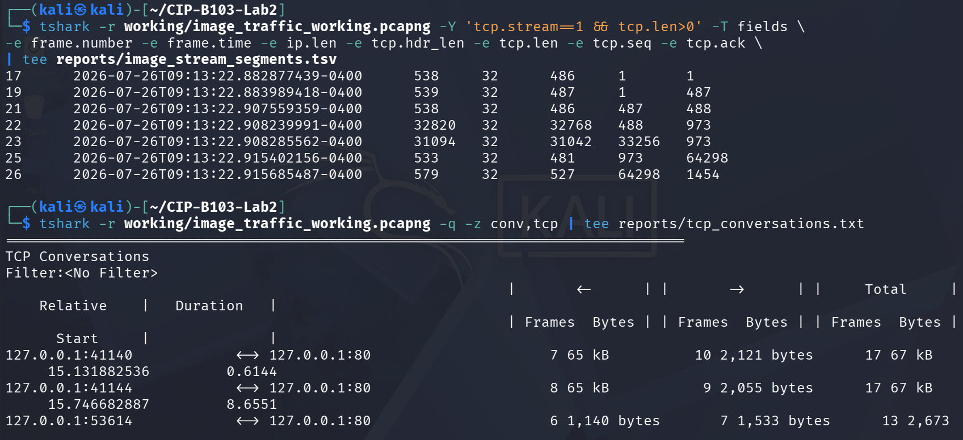
Screenshot 17: tcp.stream segment listing for the image transfer and tcp conversation summary.
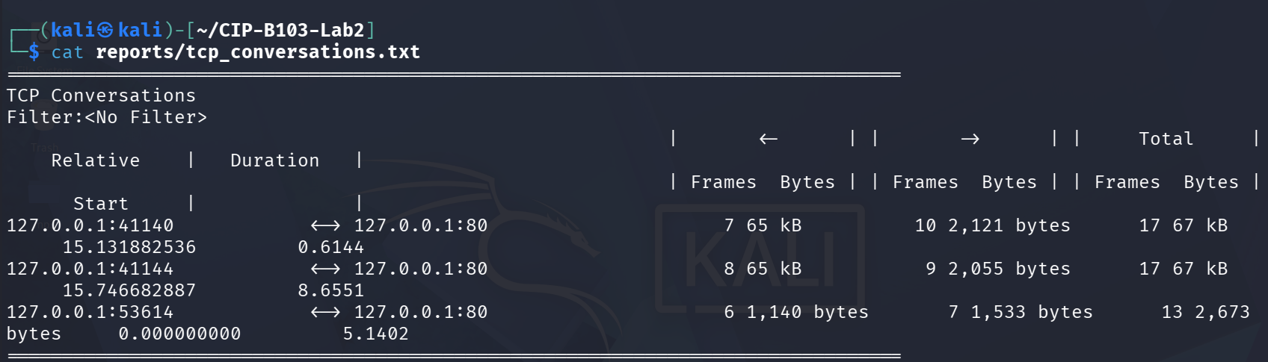
Screenshot 18: Contents of reports/tcp_conversations.txt.
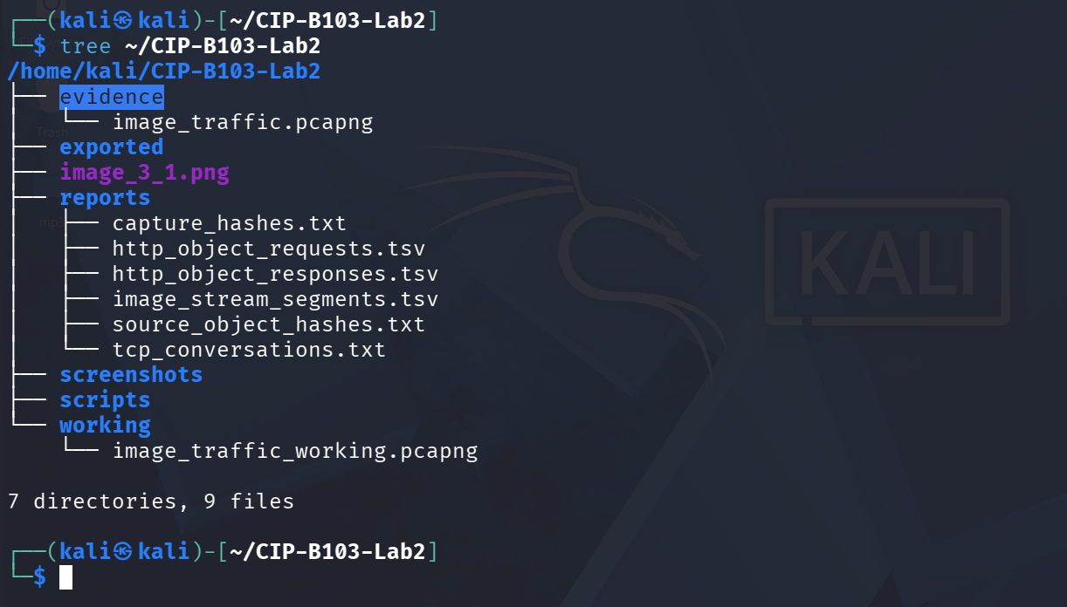
Screenshot 19: Evidence folder tree after Part D segmentation analysis.

12. Part E - Export the Embedded Image
- In Wireshark select File > Export Objects > HTTP.
- Locate lab_photo.jpg by hostname, content type or filename and save it under exported.
- Alternatively, use tshark object export as shown below.
- Compare file type, size and SHA-256 hash of the exported image with the source image.
mkdir -p exported/http_objects
tshark -r working/image_traffic_working.pcapng --export-objects http,exported/http_objects
find exported/http_objects -maxdepth 1 -type f -ls
file exported/http_objects/*
sha256sum /var/www/html/lab_photo.jpg exported/http_objects/* | tee reports/extracted_object_hashes.txt
Integrity Interpretation
Matching hashes prove byte-for-byte recovery. A different filename is not a problem if size, type and hash match. A different hash requires investigation of incomplete capture, browser content transformation, a different requested object or export error.
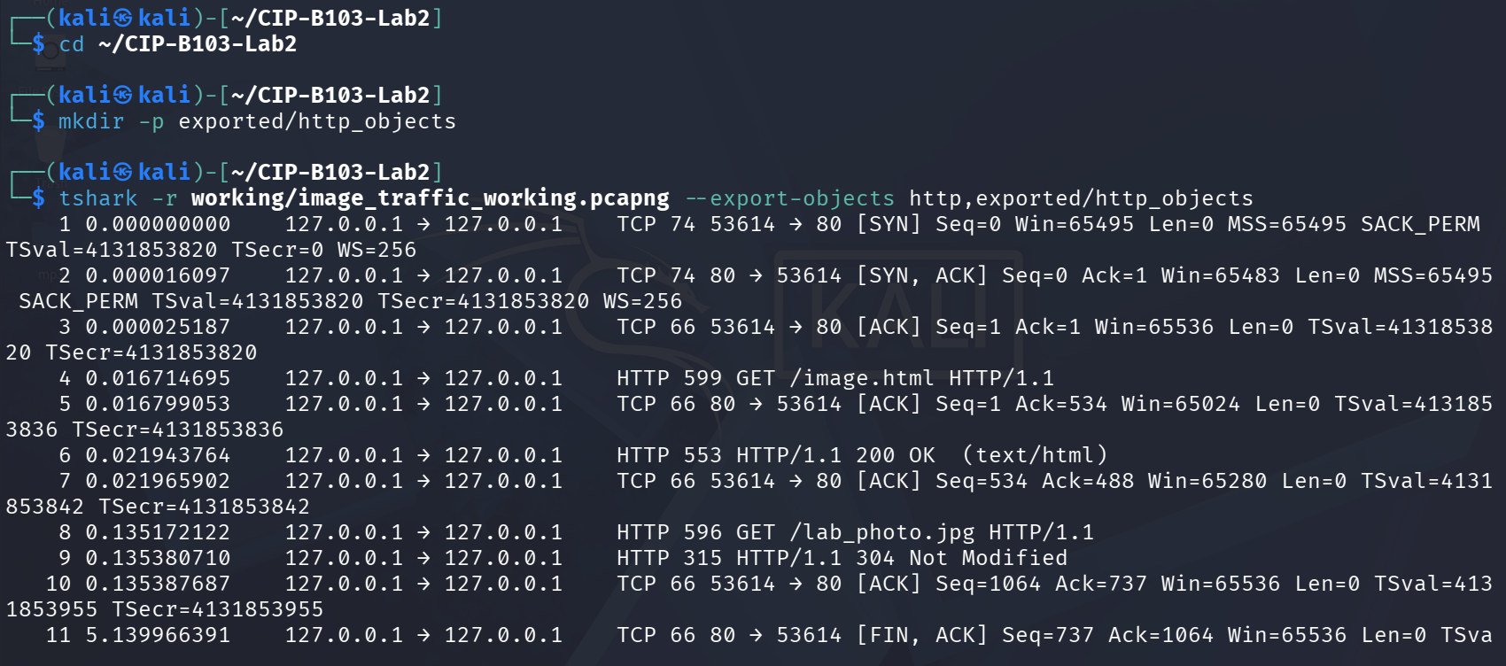
Screenshot 20: tshark --export-objects http extracting HTTP objects from the working capture.
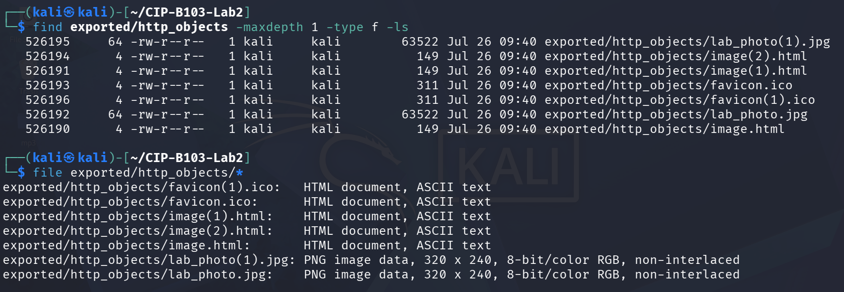
Screenshot 21: Exported HTTP objects listed and identified with file (image.html, lab_photo.jpg, favicon.ico).
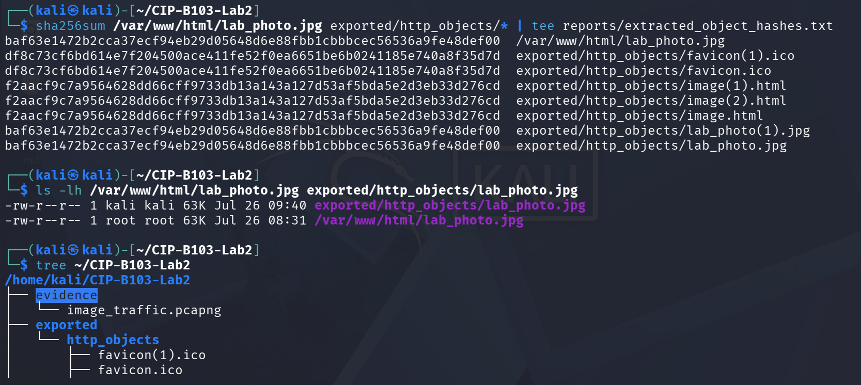
Screenshot 22: SHA-256 comparison of the source and exported lab_photo.jpg (matching hashes).
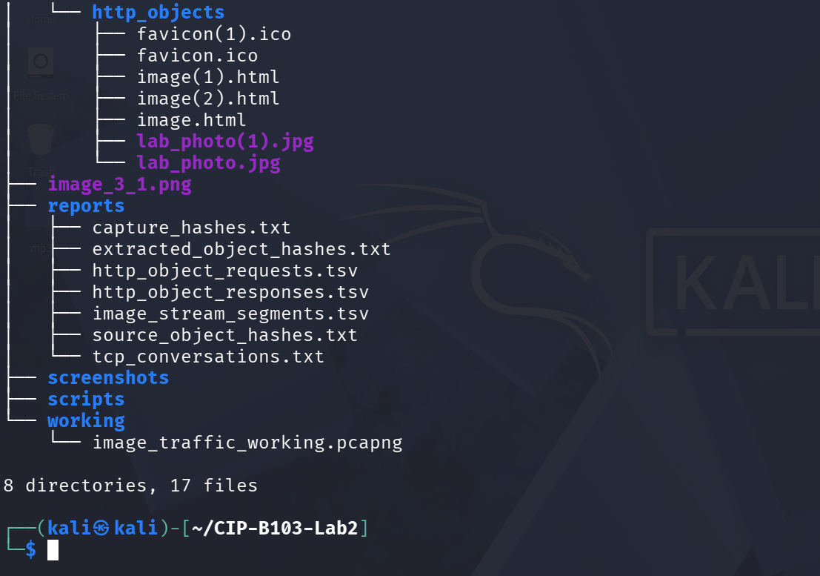
Screenshot 23: Full evidence folder tree after Part E object extraction.

13. Part F - Compare curl and Browser Behaviour
Run curl against image.html in a new capture. By default, curl retrieves the HTML but does not automatically fetch the referenced image. Explain why the image request is absent unless you request it separately.
sudo tshark -i lo -f 'tcp port 80' -a duration:20 -w evidence/curl_only.pcapng &
sleep 2
curl -v http://127.0.0.1/image.html -o /tmp/image_page.html
wait
tshark -r evidence/curl_only.pcapng -Y 'http.request' -T fields -e http.request.uri | tee reports/curl_requested_objects.txt
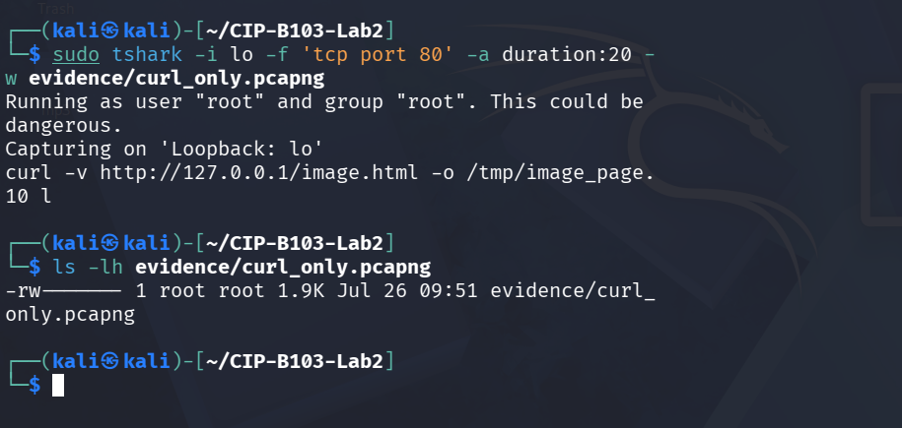
Screenshot 24: curl -v request to image.html only, showing no automatic follow-up image request.
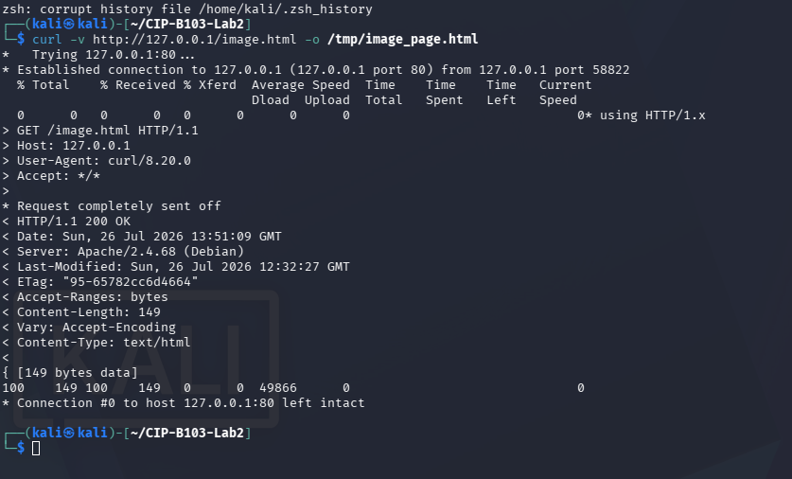
Screenshot 25: Full curl -v headers and response for the HTML-only request.
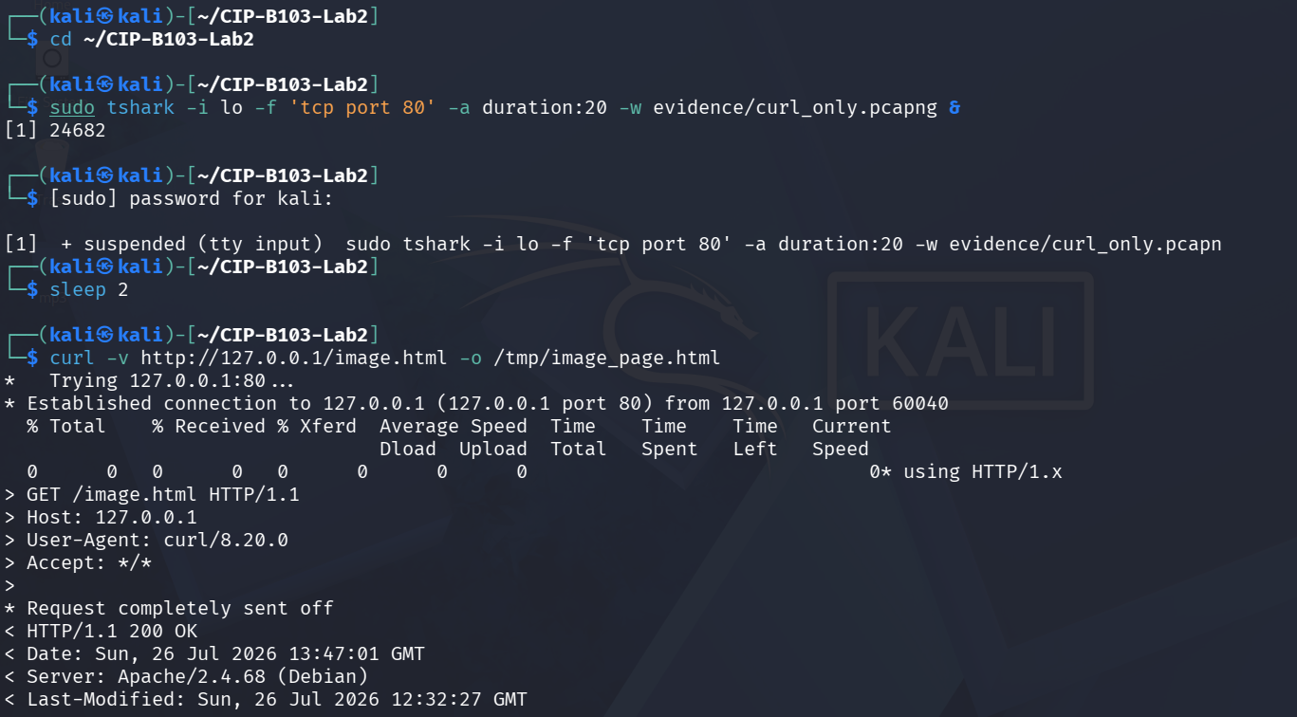
Screenshot 26: New tshark capture (curl_only.pcapng) started before repeating the curl request.
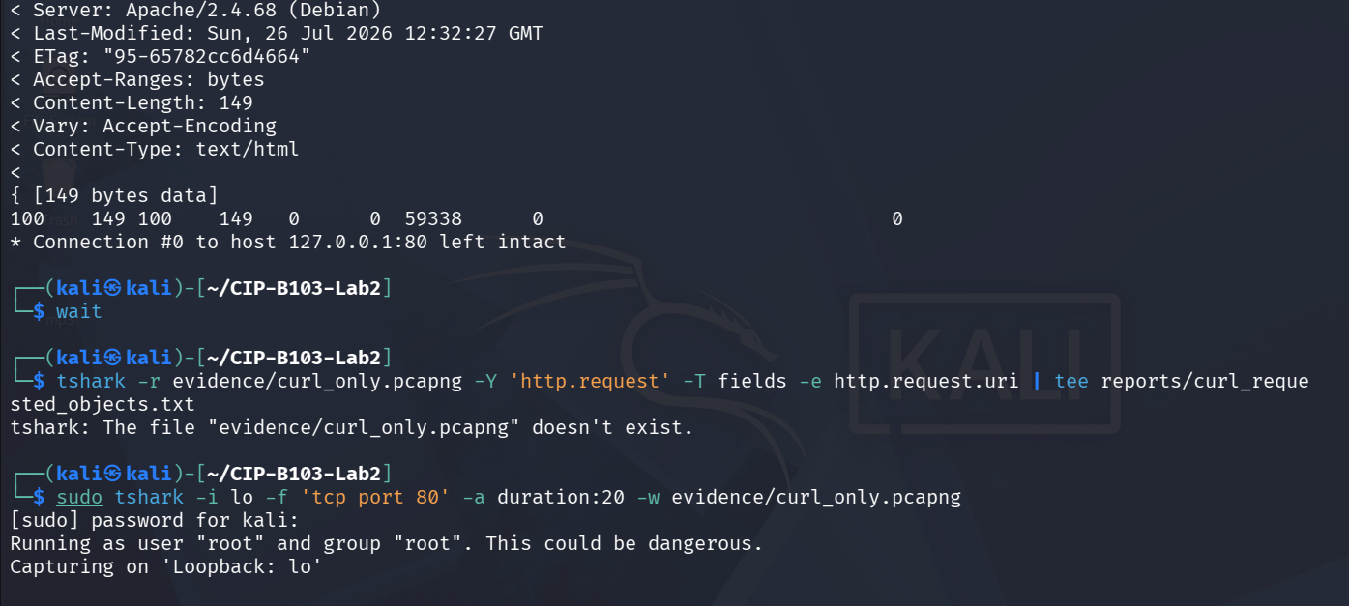
Screenshot 27: curl response headers captured during the curl-only capture window.
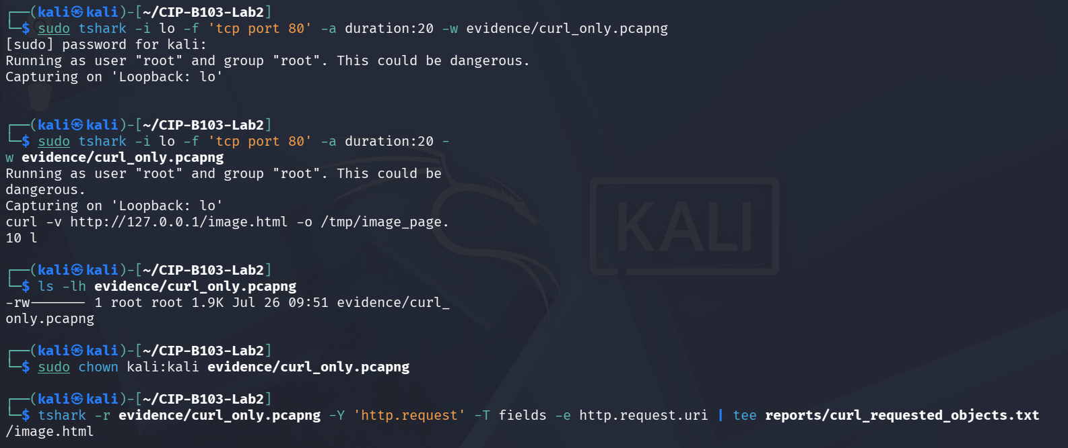
Screenshot 28: http.request filter on curl_only.pcapng confirming only /image.html was requested.

14. Required Forensic Findings
Finding | Student Observation
Number of HTTP requests | 8 total GET requests across 3 TCP streams (2 for image.html, 2 for lab_photo.jpg, 2 for favicon.ico, plus 1 image.html + 1 lab_photo.jpg in an earlier cached reload)
HTML request URI and timestamp | GET /image.html — frame 17, 2026-07-26 09:13:22.882877 (tcp.stream 1)
Image request URI and timestamp | GET /lab_photo.jpg — frame 21, 2026-07-26 09:13:22.907559 (tcp.stream 1)
HTTP response codes | 200 OK (image.html), 200 OK (lab_photo.jpg), 404 Not Found (favicon.ico); 304 Not Modified observed on an earlier cached reload
Image content type | image/jpeg (per HTTP Content-Type header; note the underlying file is actually PNG-encoded per file/identify output — served under a .jpg name)
Reported Content-Length | 63522 bytes
Number of reassembled TCP segments | 7 segments on tcp.stream 1 (frames 17,19,21,22,23,25,26); the 63522-byte JPEG object itself spans 2 large data segments (frames 22 and 23, tcp.len 32768 and 31042)
Sum of TCP payload lengths | 66,277 bytes total tcp.len across the 7 segments in stream 1 (486+487+486+32768+31042+481+527), consistent with the ~67 kB reported for that conversation
Original image SHA-256 | baf63e1472b2cca37ecf94eb29d05648d6e88fbb1cbbbcec56536a9fe48def00
Extracted image SHA-256 | baf63e1472b2cca37ecf94eb29d05648d6e88fbb1cbbbcec56536a9fe48def00
Hash comparison conclusion | Match — original and Export Objects-recovered lab_photo.jpg are byte-for-byte identical (same SHA-256), confirming successful, unaltered reconstruction from the captured TCP segments.
curl/browser difference | curl retrieved only /image.html (Content-Length 149) and issued no follow-up request for lab_photo.jpg, whereas the browser parsed the HTML and automatically issued a second GET for the embedded image plus a favicon probe — curl does not parse or render HTML, so it never discovers embedded resource references.

Required Screenshots Checklist
☐ Webpage showing the embedded image.
☐ Source image type, dimensions, size and hash.
☐ Capture of the browser request.
☐ HTTP request list showing HTML and image GETs.
☐ Image response headers.
☐ Reassembled TCP segment list.
☐ Export Objects window.
☐ Recovered image opened successfully.
☐ Original and recovered SHA-256 comparison.
☐ curl-only capture showing requested objects.

Student Report Template
- Executive summary and scope.
- Evidence acquisition and integrity hashes.
- HTTP request/response inventory.
- TCP segmentation and reassembly analysis.
- Object extraction method.
- Hash-based integrity conclusion.
- curl versus browser explanation.
- Limitations and recommendations.
- Screenshots and command appendix.

Submission Requirements
- One PDF report named CIP-B103-Lab2_RegNo_FullName.pdf.
- The original or generated PCAP/PCAPNG evidence file and its SHA-256 hash text file.
- A reports folder containing exported CSV/TXT command output and any recovered objects.
- Screenshots must be readable, numbered and referenced in the report narrative.
- Compress the report and evidence outputs into one ZIP named with your registration number and lab number.
- Do not submit passwords or decoded credentials in public discussion channels; include them only in the protected assessment submission where required.

Marking Rubric (100 Marks)
Assessment Area | Marks | What the Instructor Will Check
Preparation and source objects | 10 | Valid webpage and authorized image, with baseline hashes.
Capture quality | 15 | Complete browser capture with HTML and image requests.
HTTP analysis | 20 | Correct object requests, responses, types and timestamps.
Segmentation/reassembly | 20 | Accurate segment identification, lengths and explanation.
Object extraction and hashing | 25 | Recovered image opens and hash comparison is correctly interpreted.
Report quality | 10 | Professional evidence narrative and screenshots.

Instructor Quick Answer Guide
Checkpoint | Expected Observation
Expected object requests | At least image.html and lab_photo.jpg.
Typical response status | HTTP 200 OK.
Image response type | image/jpeg or image/png.
Reassembly | One HTTP object may span multiple TCP segments.
Browser behaviour | Browser parses HTML and fetches embedded resources.
curl behaviour | curl normally retrieves only the explicitly requested URL.

Command Reference Summary
Command | Purpose
http.request | List requested HTTP objects.
http.response | List HTTP responses.
tcp.len | TCP payload length field.
File > Export Objects > HTTP | Recover transferred files.
tshark --export-objects http,DIR | Command-line HTTP object extraction.
sha256sum | Verify recovered object integrity.

Academic Integrity and Authorization Statement
Student Declaration
I confirm that I completed this lab in an authorized environment, preserved the supplied evidence, did not target any third-party system, and accurately documented my own commands, observations and conclusions.

